NAME: S. DHARANI
REG NO: 192472364
COURSE CODE: DSA0401
NUMPY / PANDAS ANALYSIS – QUESTIONS AND ANSWERS
QUESTION 19: 95% CONFIDENCE INTERVALS FOR BLOOD PRESSURE REDUCTION
AIM:
To calculate the 95% confidence intervals for the mean blood-pressure reduction in drug and placebo groups.
ALGORITHM:
1. Import NumPy and SciPy stats.
2. Enter the reduction values for both groups.
3. Calculate the sample mean and standard error.
4. Use the t-distribution to calculate the 95% confidence interval.
5. Display the confidence intervals.
CODE:
import numpy as np
from scipy import stats
drug = np.array([12, 10, 15, 11, 14, 13, 9, 12, 16, 11])
placebo = np.array([4, 5, 3, 6, 2, 4, 5, 3, 6, 4])
def confidence_interval(data):
mean = np.mean(data)
se = stats.sem(data)
low, high = stats.t.interval(0.95, len(data)-1,
loc=mean, scale=se)
return mean, low, high
print("Drug:", confidence_interval(drug))
print("Placebo:", confidence_interval(placebo))
INPUT:
Sample reduction values for drug and placebo groups are included in the code.
OUTPUT:
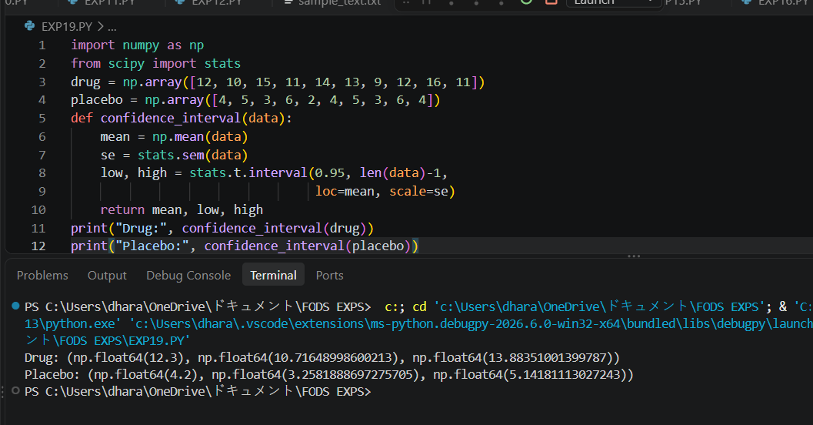RESULT:
The 95% confidence intervals were calculated successfully.
NOTE: Sample values are used because the question does not provide the actual 50 patient measurements. Replace the arrays with the given data.

